HANDS Dissemination

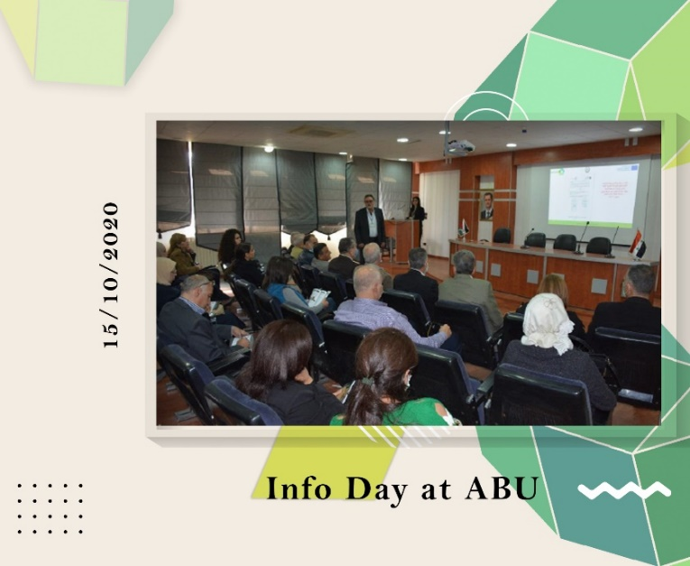
HANDS Info Day at Al Baath University (ABU)
WP 8: DISSEMINATION & EXPLOITATION
Date: Thursday, 15/10/2020
Organizer: AL Baath University (ABU) / Syria
Location: Faculty of Architectural Engineering / Blue Hall
Al-Baath University, led by Prof. Khatib, hosted a targeted Information & Open Door Day for the EU-funded HANDS project. Despite pandemic limitations, HANDS leveraged a dedicated office and engaging activities to connect with specialists, students, and institutions in architecture, engineering, and crafts. This event nurtured collaboration and solidified HANDS' presence within the university.

